**Affinity Diagram** (storyboard)

The Affinityprocess is often used to group ideas generated by Brainstorming.

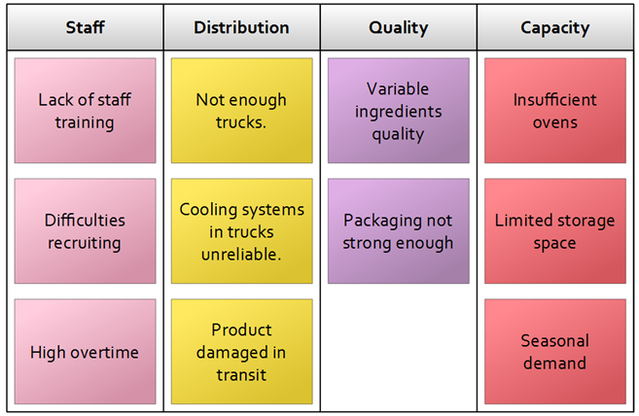

**Context Diagram**

Shows a system and the relationship of the external environment it interacts with

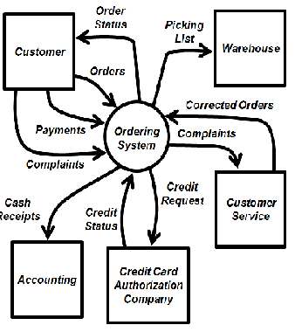

**Histogram**

Bar graph that illustrates the frequency of an event occurring using the height of the bar as an indicator.

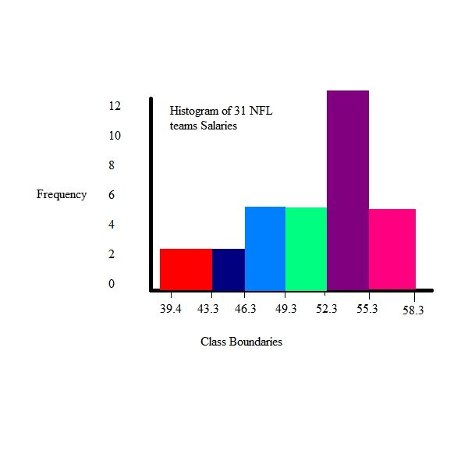

**Pareto Chart**

A Pareto chart is a specific type of histogram that ranks causes or issues by their overall influence. A Pareto chart assists in prioritizing corrective actions as the issues (commonly known as the 80/20 rule, where 80% of the problems are due to 20% of the causes).

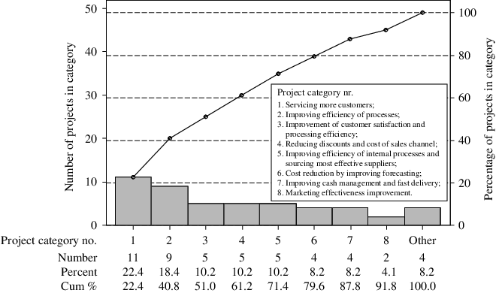

**Tornado Diagram**

A common tool used to depict the sensitivity of a result to changes in selected variables. It shows the effect on the output of varying each input variable at a time, keeping all the other input variables at their initial (nominal) values.

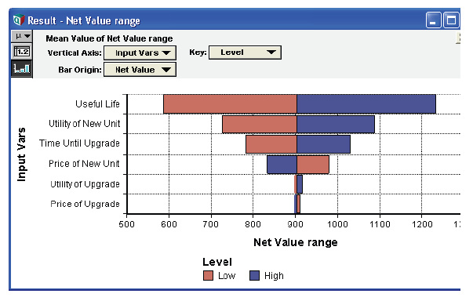

**Six Sigma**

The value of sigma of Normal Distribution are given below. These are important for the exam.

**Normal Distribution Sigma values**

|  |  |
| --- | --- |
| **Sigma** | **Percentage covered** |
| One sigma | 68.26% |
| Two sigma | 95.46% |
| Three sigma | 99.73% |
| Six sigma | 99.99% |

Based on the above table, we can see that in six sigma one out of 10,000 items can have defects. In three sigma, twenty seven out of 10,000 items can have defects.

**Decision Tree**

Which one is the best decision (choice):

Estimated Monetary Value EMV = P (probability) X I (Impact)

**Point of total assumption** (fixed-price incentive fee contracts)

Ceiling Price – Target Price

PTA = __________________________________ = Target cost

Buyer’s Share Ratio

